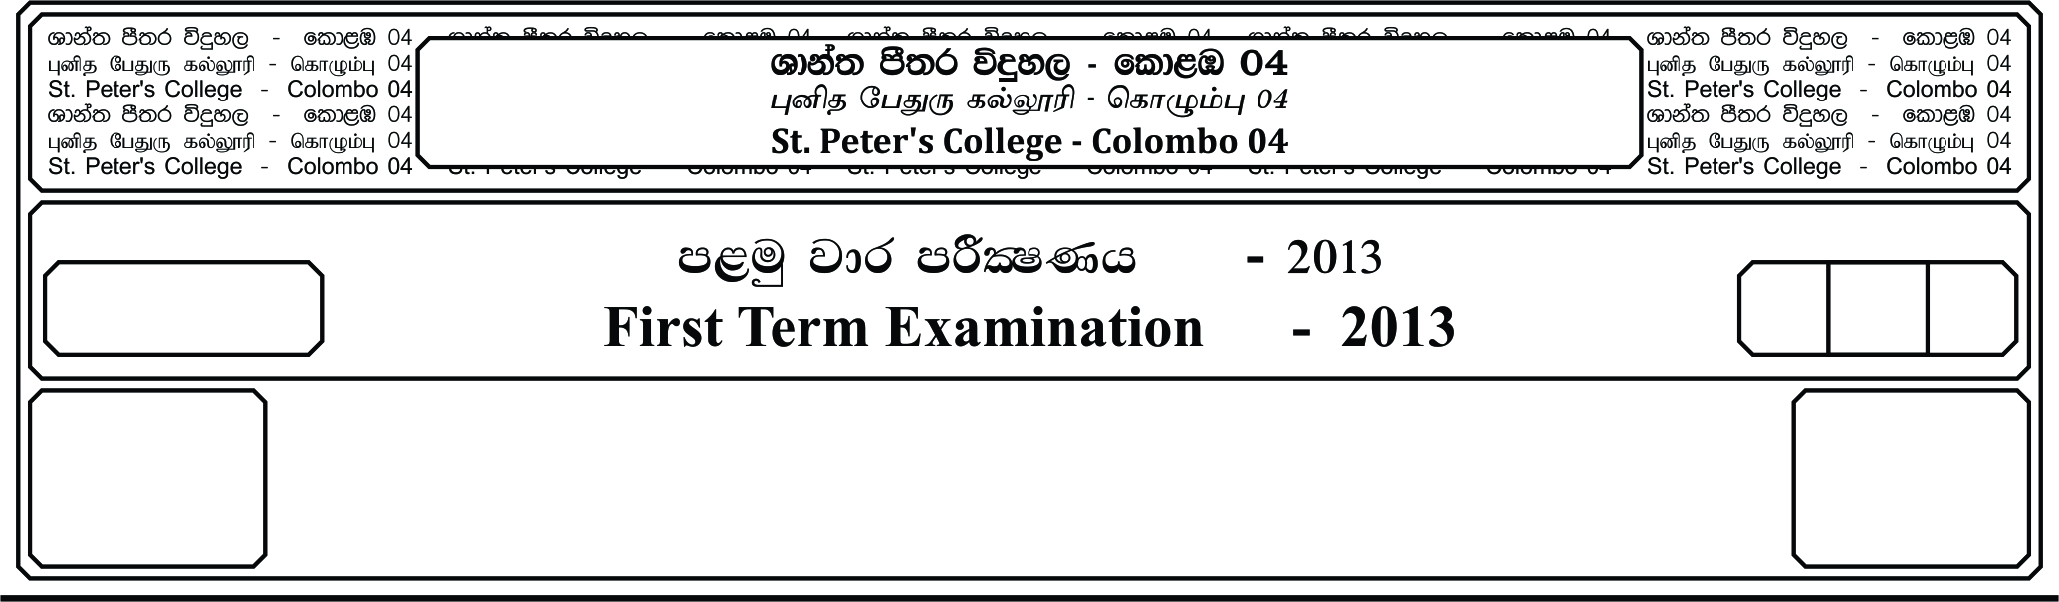

13 fY%aKsh

GRADE 13

E

meh

Hour

II

**m<uq jdr mÍCIKh - 2020**

**First Term Examination - 2020**

cSj úoHdj - »»

**BIOLOGY – II**

09

● **Structured Essay.**

**Answer all questions.**

01. (A). i. Mention 03 components transport along phloem sap.

____________________________________________________________________

____________________________________________________________________

ii. What is meant by phloem unloading?

____________________________________________________________________

____________________________________________________________________

iii. Name 2 sites where phloem loading takes place.

____________________________________________________________________

____________________________________________________________________

iv. What is the driving force of bulk flow?

____________________________________________________________________

v. Briefly explain how change at the sink, of the beginning of the process.

____________________________________________________________________

____________________________________________________________________

____________________________________________________________________

vi. Glucose convertd to another compound before it transport along the respective tissue.

Mention 02 special features which make it more suitable to transport. (Than glucose).

____________________________________________________________________

____________________________________________________________________

____________________________________________________________________

(B). i. What is meant by stomatal transpiration?

____________________________________________________________________

____________________________________________________________________

____________________________________________________________________

ii. Write 03 external factors affect on transpiration.

____________________________________________________________________

____________________________________________________________________

____________________________________________________________________

iii. What is meant by root pressure?

____________________________________________________________________

____________________________________________________________________

iv. Write how guttation differ from transpiration.

____________________________________________________________________

____________________________________________________________________

____________________________________________________________________

v. Draw a fully labed diagram of experimental setup to measure transpiration rate.

vi. Write one hepothesis follow in the experiment.

(C). i. What is meant by alternation of generation in plants?

____________________________________________________________________

____________________________________________________________________

____________________________________________________________________

Diecous gametophyte

**A**

**X**

Sporangia

**Y**

Sporophyte

**B**

**C**

**D**

**Z**

**P**

¸¸'

a. Identify the above plant.

____________________________________________________________________

b. Label A - D and x - z.

A X

B Y

C Z

D

iii. Name corresponding stractures to A in *Selaginella*.

____________________________________________________________________

____________________________________________________________________

iv. Write the 02 differences between gametophyte of above mentionred plant in the chart

and embryosac.

____________________________________________________________________

____________________________________________________________________

____________________________________________________________________

v. Relate structural difference between pollen tube of *Cycas* and *Anthophyta* to their main

function.

____________________________________________________________________

____________________________________________________________________

02. (A). i. What in meant by animal tissue?

____________________________________________________________________

____________________________________________________________________

____________________________________________________________________

ii. Write main charcteristics of animal epithelial tissue.

____________________________________________________________________

____________________________________________________________________

____________________________________________________________________

____________________________________________________________________

iii. Mentioned the respective epithelial tissue found in following locations.

**Location Tissue**

a. Kindeny tubule

b. Duodenum

c. Right ventricle

d. Vagina

iv. Write 04 main functions of connective tissues.

____________________________________________________________________

____________________________________________________________________

v. Write 03 cell types found in loose connecttre tissue.

____________________________________________________________________

____________________________________________________________________

vi. Write one function of each of them.

____________________________________________________________________

____________________________________________________________________

____________________________________________________________________

____________________________________________________________________

(B). i. Plant body consist of different types of tissues. Write 03 functions of ground tissue

system.

____________________________________________________________________

____________________________________________________________________

____________________________________________________________________

ii. Identity the following diagram.

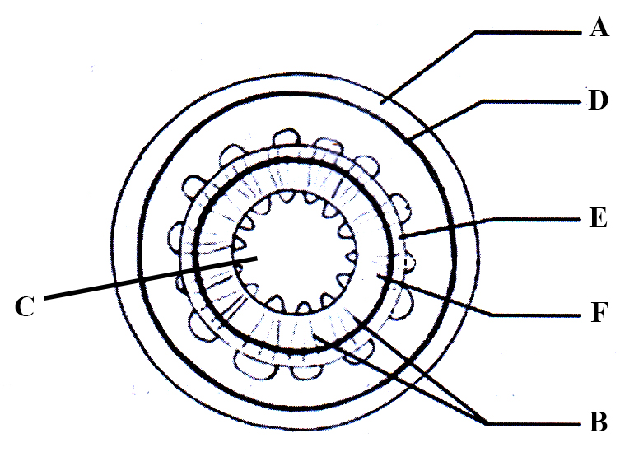

iii. Label A, B, C

A - D -

B - E -

C - F -

iv. What is meant by bark.

____________________________________________________________________

____________________________________________________________________

____________________________________________________________________

v. What is the difference between hard wood and soft wood.

____________________________________________________________________

____________________________________________________________________

(C). i. Phisiology of plants directly affectd by external factors.

Explain the how flowering control by external factors.

____________________________________________________________________

____________________________________________________________________

____________________________________________________________________

ii. Explain statolith hypothesis in plants.

____________________________________________________________________

____________________________________________________________________

____________________________________________________________________

____________________________________________________________________

iii. Complete the following table regarding plant hormone.

**Function** **Hormone**

a. Promote dessication tolerance

b. Promote the root hair formation.

c. Regulate transition from juvenile.

to adult phase.

d. Modify apical dominance

e. Promote the vertical growth seedlings.

iv. What is meant by biotic stress?

____________________________________________________________________

____________________________________________________________________

v. Write 02 pre-existing chemical defense mechanisms found in plants for biotic stress.

____________________________________________________________________

____________________________________________________________________

____________________________________________________________________

**Essay Questions.**

01. a). Explain the three path ways of radial transportation of water and minerals in vascular

plants.

b). Explain the process of upward movement of water and minerals in plants.

02. a). Explain the structural and functional adaptations of stomach for digestion and

absorption of food.

b). Explain the chemical digestion and absorption of small intestine.

03. Write short notes.

a). Feeding mechanisms of animals. b). Photomorphogenesis.

c). Microscopic Structure of liver.